Week 3 – Homework

#**************************

Please see the attached word document for the Homework.

#**************************

Please note all homework is due submitted on-line by 1PM CST (Dallas) on Wednesday September 20.

For now, send me an email to [cmaybin@smu.edu](mailto:cmaybin@smu.edu) titled MSDS_8310 - [Last Name] - Week 3 Homework. For example, my submission would be titled MSDS_8310 - Maybin - Week 3 Homework. In the email should be the following (2) attachments containing the answers to the questions below:

* 1 Word document: Questions 1 – 6, 7 (written answers)
* 1 R File: Question 7 – code

Please keep all written answers short – say no more than 4 sentences.

Regards,

Chad

#************************

Homework Section

#************************

Question 1 – “Rule of 72” :

1. At 3.6% return, how long will it take an investment to double?

To double an investment with a 3.6% return, it would take 20 years

1. If an investment doubles in 5 years, what is the approximate rate of return under the rule of 72? The rule of 72 would say that this investment was receiving an approximate return of 14.4% per year

Question 2 – Given the following Isoquant graph (all graphs copied from HW/other videos):

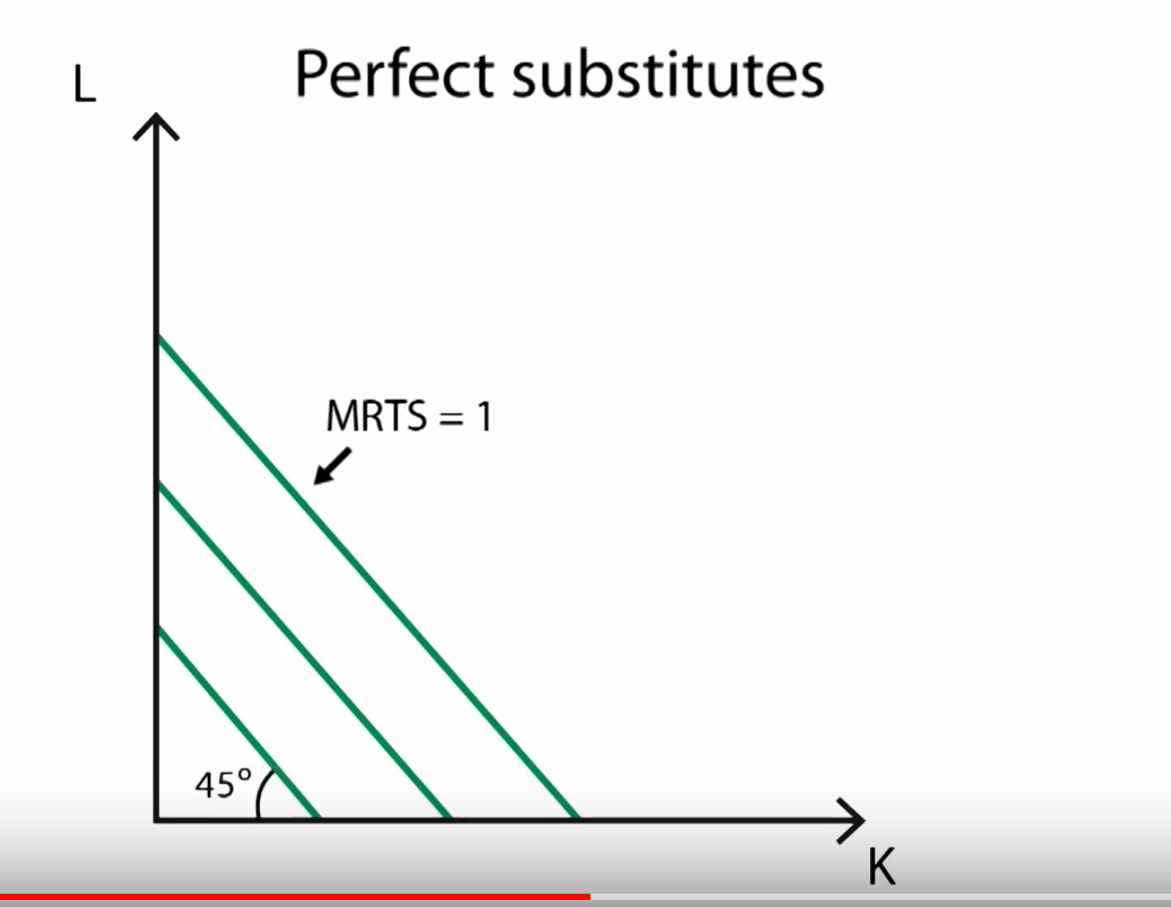

1. What does “substitutes” mean? A substitute is something that can be swapped for the original item. A perfect substitute can replace another unit at the same rate.
2. What is this telling us about the relationship between Labor and Capital? This graph is telling us that at any of the levels of production depicted, we can swap labor for capital at the same rate to produce that specified amount of output.
3. Why would this be a “straight” line with a 45 degree angle? Is that relevant? This line is 45 degrees, because labor and capital can be perfectly substituted for each other at each relevant level of production. We get a 45 degree line, because the slope of the line is equal to 1 (1/1). This is relevant for the case highlighted above, because labor and capital are not always perfectly substitutable and this reflects the ratio at which managers can trade in and out of inputs for a given level of production

Question 3 – Given the following Isoquant graph:

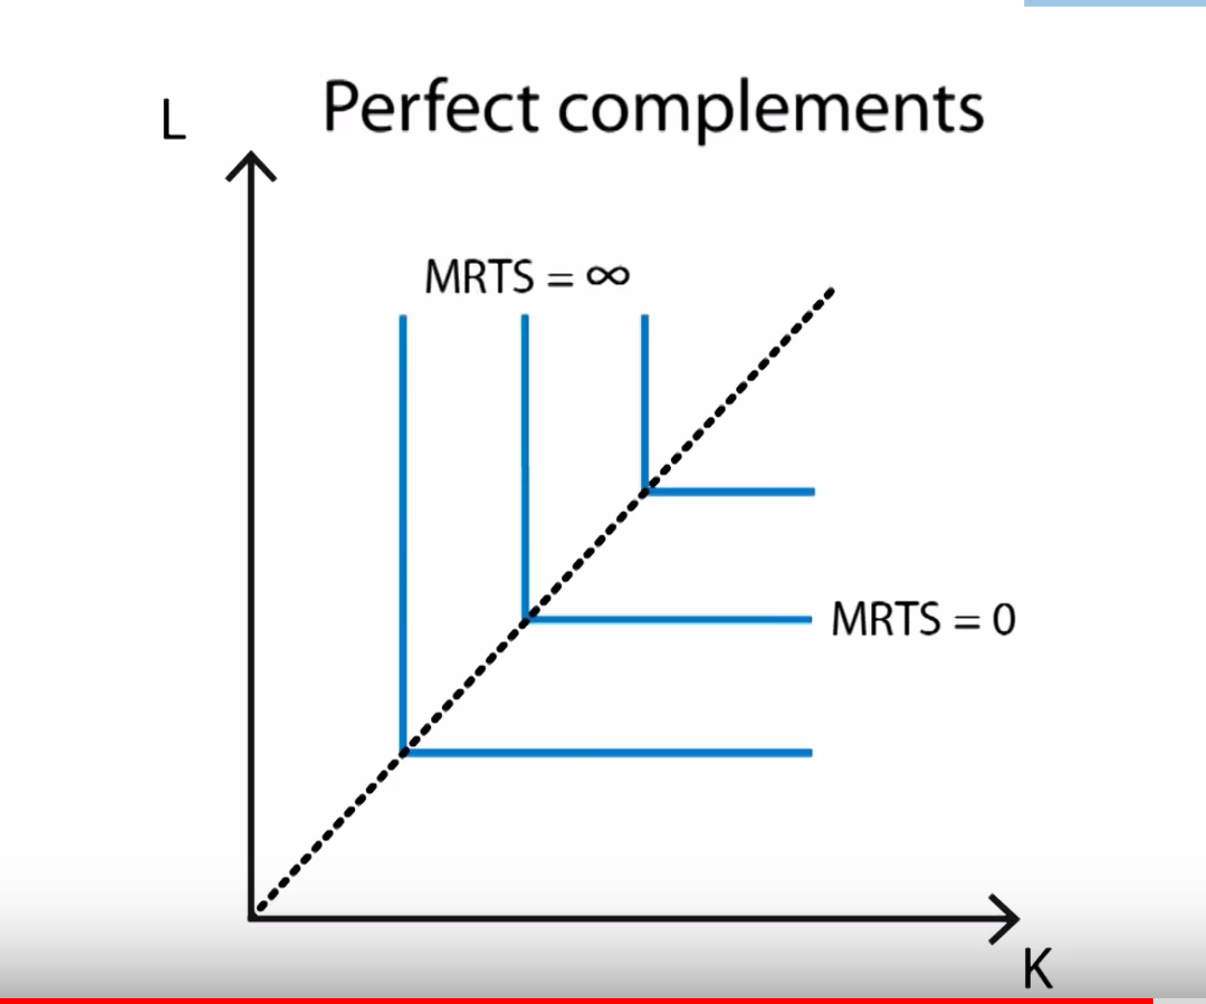

1. What does “complements” mean? Compliments mean that the two items must be used together, in this case, for production at a certain level of output.
2. What is this telling us about the relationship between Labor and Capital? This graph is telling us that in order to produce a given level of output, we must essentially employ the levels of labor and capital at the elbow in the isoquant line. Any deviation from this essentially means that we will be employing too much of one input to be considered optimal.
3. Why would this be a “straight” line with 90 degree angles at the meeting of Labor and (K) Capital? Is that relevant? This would be a straight line, because there is a fixed ratio of capital and labor which must be employed in a complementary fashion in order to optimally allocate resources. For instance, if we were to employ more labor than the amount at the elbow in the isoquant curve, we would be wasting resources due to the complementarity of the items. We would have employees standing around because they would not have the capital items needed in order to be productive.

Question 4 – Given the following **Isocost** graph:

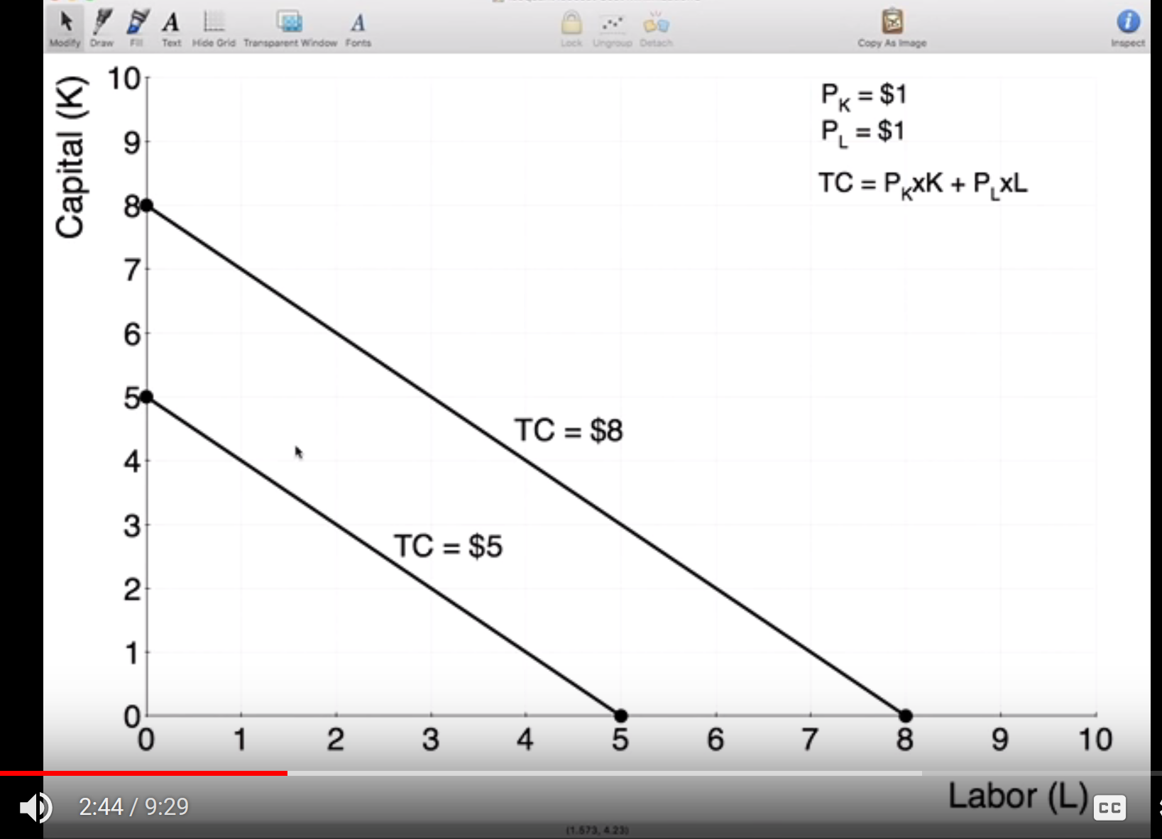

1. What is this telling us about the relationship between Labor and Capital? This graph is telling us that for any given total cost, the lines displayed represent the mix of labor and capital needed to maintain that total cost structure.
2. Why would this be a “straight” line with a 45 degree angle? Is that relevant? This would be a straight line if each unit of labor and capital has the same cost. This is definitely relevant when running a business, because managers make business decisions based on the tradeoff between costs.

Question 5 – Given the following graph:

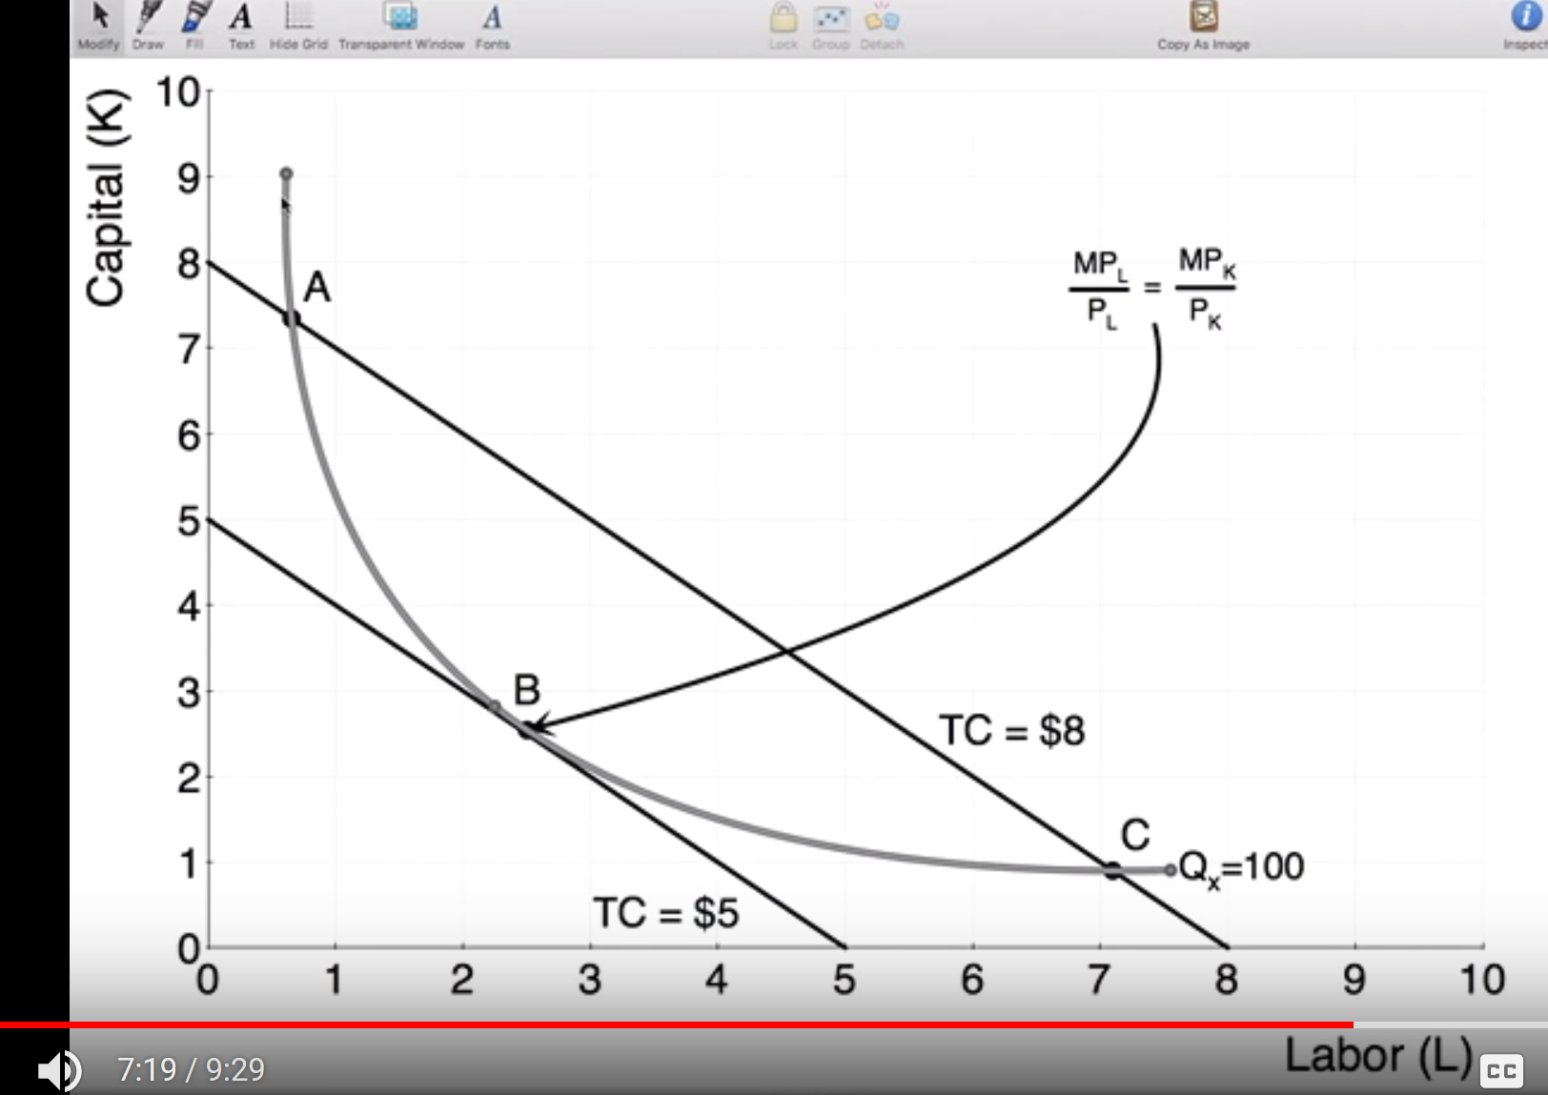

1. What is this telling us about the optimal production? This point is telling us that for 100 units of production, the optimal level of labor and capital is about 2.5 units for each respectively. This also tells us that we can produce this amount for a cost of $5.
2. Why is point B superior to points A and C? Point B is superior to points A and C, because point B represents a lower cost of production for the same 100 units of output given by the isoquant curve.

Question 6 – Given the following graph:

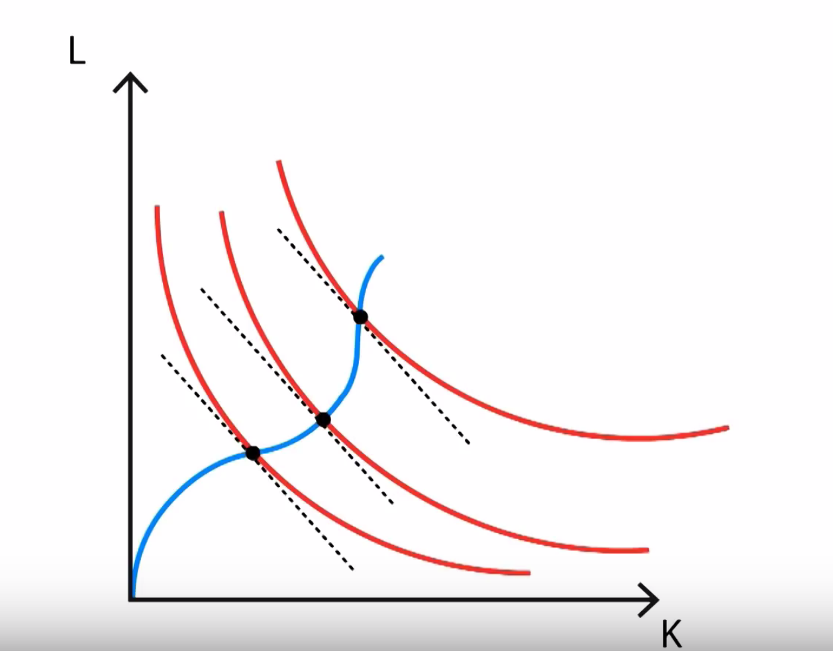

1. What are the “dotted” lines on this graph? The dotted lines on the graph represent the optimal intersection with the isocost curve.
2. What are the red lines on this graph? The red lines are the isoquants for differing levels of production
3. What is the black circle (point) on the red lines where the dotted lines touch? What does this mean? These black dots are the points where the isocost curve just touches the isoquant curves. These points represent optimality between cost and production abilities.
4. Why are the red lines slightly “askew” from each other? What is that telling us? Does it make sense in the real world? The red lines are slightly askew, because the relationships between labor and capital are not fixed at each level of production. In order words, as we substitute inputs at each level of production, the tradeoff rates may change due to availability of resources, needs for a complement at a given level of employment of inputs, and a myriad of other production factors.
5. What is the name of the blue line? What is this line potentially telling us? This blue line is the isocline line. This line allows us to create a continuous line which shows us the optimal mix of labor and capital for every level of production.
6. How does the “Law of Diminishing Returns” apply here? The law of diminishing returns applies here at the ends of the isoquant curves. This basically says that you will reach a certain level at which the benefit of hiring one more unit of input of input, be it labor or capital, tends to be less productive than the previous unit employed.

Question 7 – Problem #2 (a) (page 100) - Kleiber, Christian; Zeileis, Achim. Applied Econometrics with R (Use R!) (Page 100). Springer New York. Kindle Edition.

Note: R code to pull data:

##

library("AER")

data("HousePrices")

##

2. Estimate a regression for the HousePrices data taken from Anglin and Gen¸cay (1996), which contain prices of houses sold in the city of Windsor, Canada, during July, August, and September 1987. These data are also used in the textbook by Verbeek (2004).

(a) Fit a multiple linear regression model to the logarithm of the price, using all remaining variables as regressors. Experiment with models containing lot size, number of bathrooms, number of bedrooms, and stories in logarithms and in levels, respectively. Which model do you prefer (Hint: use anova…)?